Ex. No. 8 | DATA SCRAPING IN UI PATH STUDIO
Date of Exercise | 26/02/2026

AIM
To perform data-scraping using UiPath.
DESCRIPTION
This experiment demonstrates how to perform data scraping from a website using UiPath Studio. Data scraping is the process of extracting structured information from web pages and storing it for further use. In this experiment, the automation bot opens a browser and navigates to the Amazon website, where it searches for “Automation books.” Using the Extract Table Data activity, the bot identifies and captures relevant details such as book names and prices by selecting columns directly from the webpage. The extracted data is then stored in a structured format and written into an Excel file using the Write Range Workbook activity, with headers included for clarity. This process allows multiple records to be captured efficiently based on the specified number of items. Overall, the experiment highlights how UiPath simplifies web data extraction, reduces manual effort, saves time, and ensures accurate collection of large amounts of data from online sources.
PROCEDURE:
Step 1: Open UiPath studio and click process to start a new project.
Step 2: Create a new blank process by giving a name and give create.
Step 3: Click Open main workflow.
Step 4: You will get the main workflow.
Step 5: Open browser and search amazon.in in the browser.
Step 6: From activities select use browser or application and drop it. And indicate the browser in it.
Step 7: For activities select type into. Then indicate the search bar and type “Automation books”. and select Click activity and indicate Go option.
Step 8: Click on extract table data from the activities.
Step 9: Click on Add column and select the 1 st book name.
Step 10: Again, add new column and select the price of the first book. We can rename the columns too in it. Then save it.
Step 11: From activities, select write range workbook. Create a blank excel sheet and save it then indicate in the 1st column.
Step 12: Then go to properties of extract table and add number of items required in it.
Step 13: In properties of write range workbook, select the add header option.

OUTPUT:
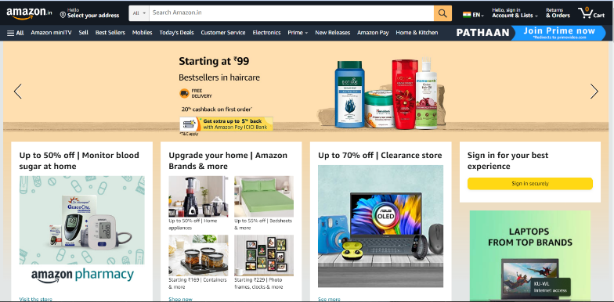
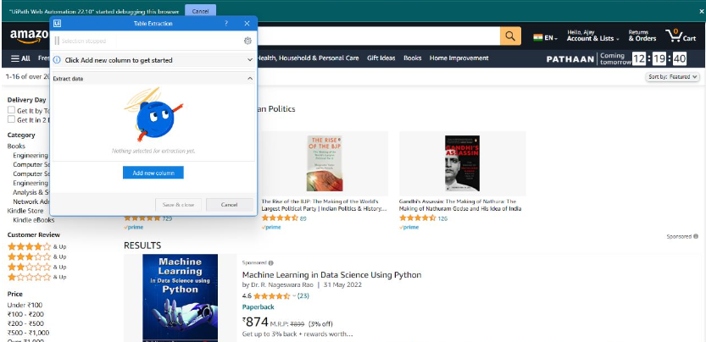

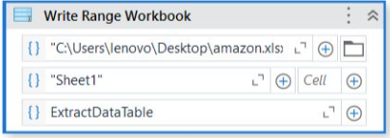
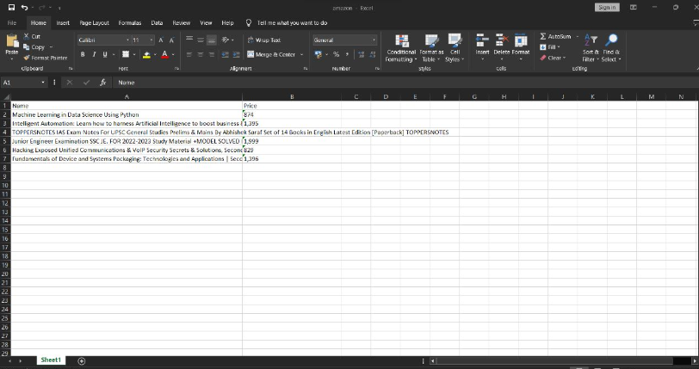

Result:
Thus, we successfully completed the data scraping using UiPath studio.

